**Algebra 3-4 Name: ____________________**

# 2.6-2.7 Family of Functions and Absolute Value Quiz Block: ________

**For problems 1 – 2, describe the transformation of f(x)=.**

1. 2.)

**For problems 3-4, describe the absolute value transformation.**

3.) $g\left(x\right)=\left|x+2\right|-1$ 4.) $g\left(x\right)=-5\left|x-4\right|+3$

For problems 5-6, graph the absolute value equation.

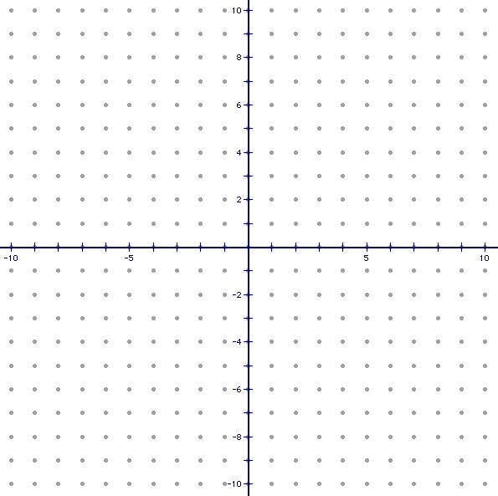**5.**   **6.** 

**For problem 7, use the following information to answer the problem.**

**7.** A cereal manufacturer has a tolerance of 1.25 ounces for a box of cereal that is supposed to weigh 30 ounces. Write and solve an **absolute value inequality** that describes the acceptable weights for “30 ounce” boxes.